Q2: Utilize various tools such as Sublist3r and Maltego, along with the search
engine Netcraft, to discover subdomains of the target 'bbc.com'.
Additionally, please capture screenshots of your findings.

- Install Sublist3r in your linux terminal with this command: sudo apt install sublist3r
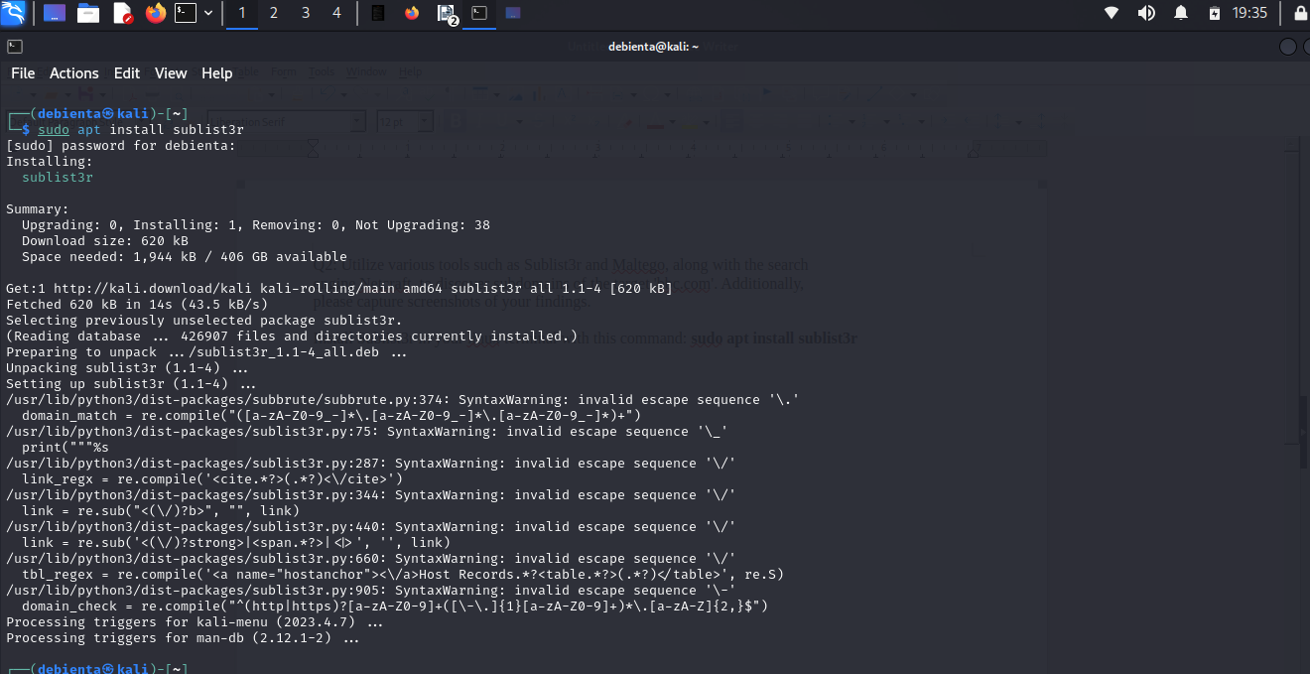
- Using Sublist3r I discovered 362 unique subdomains
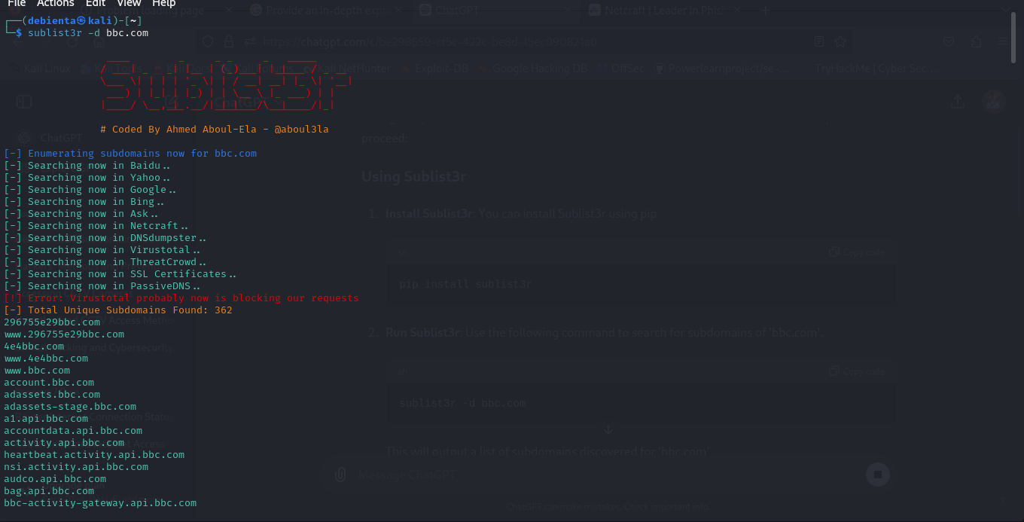
- Some of the domains include the screenshot below:
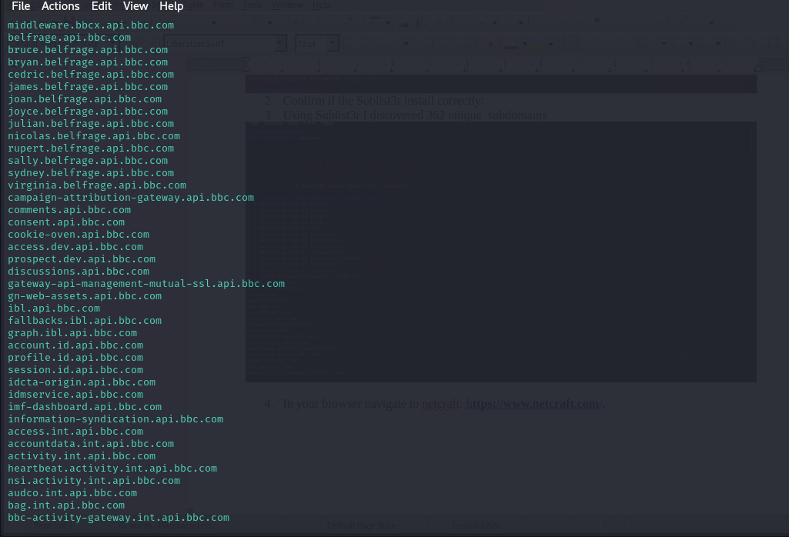
- In your browser navigate to netcraft: https://sitereport.netcraft.com/
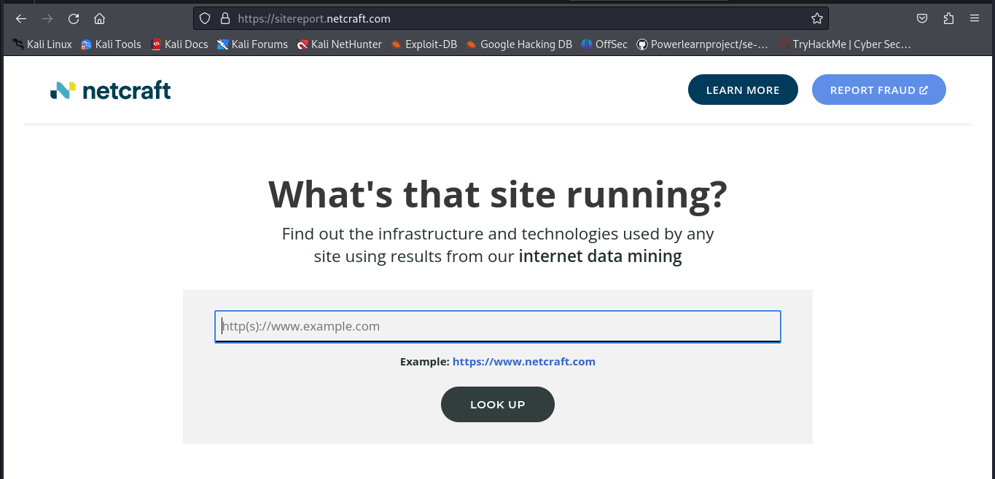
- In the search bar type “bbc.com” I was not able to discover any subdomains in netcraft.
- Download Maltego in their official website: https://downloads.maltego.com/maltego-v4/linux/Maltego.v4.7.0.deb
- Install necessary dependencies: Sudo apt update and sudo apt install default-jre
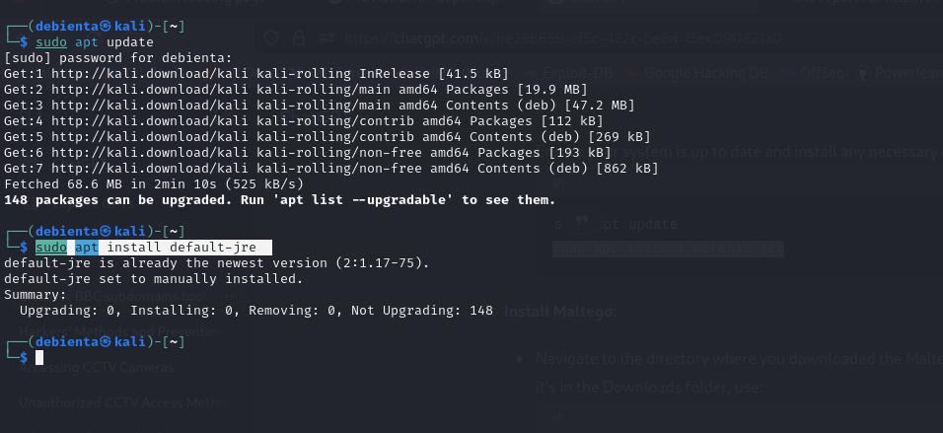
- cd Downloads or where you downloaded your maltego and install it: sudo dpkg -i maltego*.deb
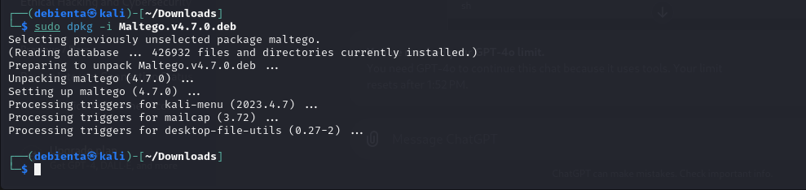
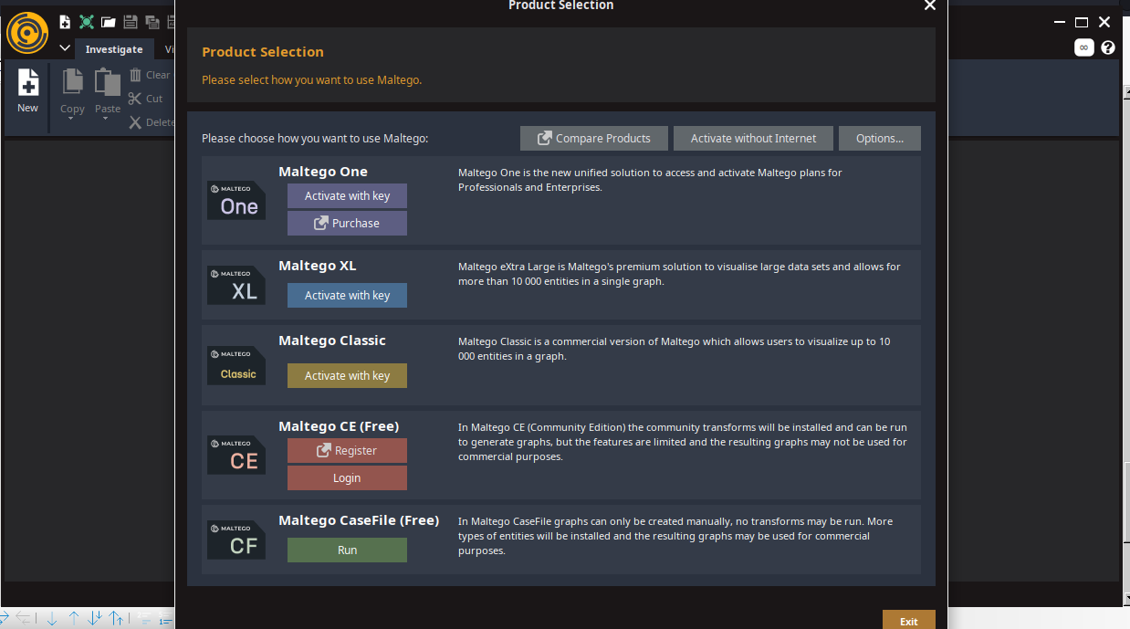
- Launch maltego in the terminal type: maltego
- Log In and Set Up Maltego: Use the Free maltego if you don’t want a licensed one in this case we will use: Maltego CE(Free)

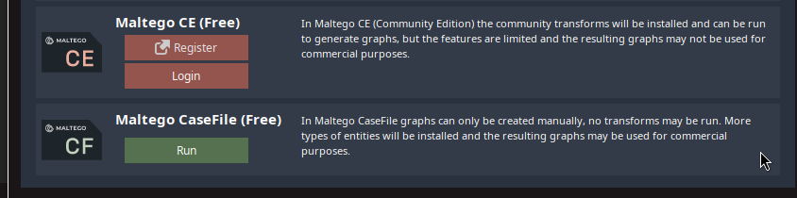
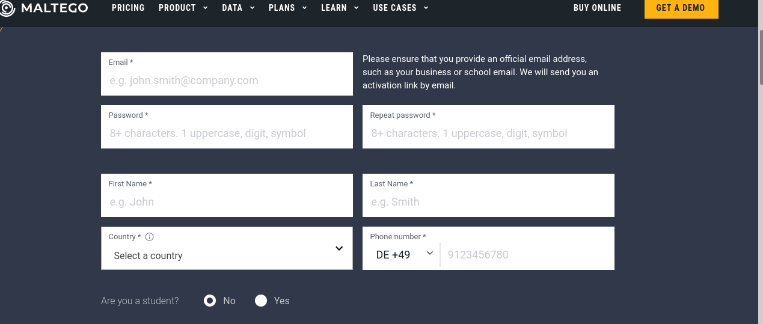
- Register if you do not have an account: once you click on register it will bring you to this page, insert all necessary information.
- Follow this steps utnil you finish configuring your maltego
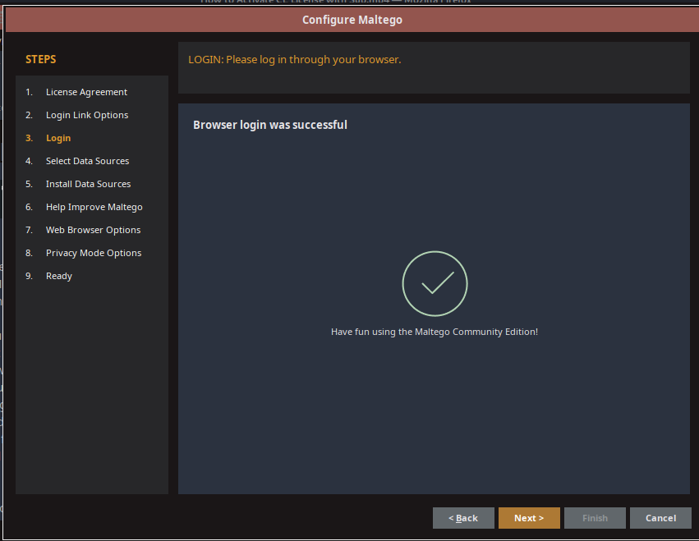
- Open a new graph
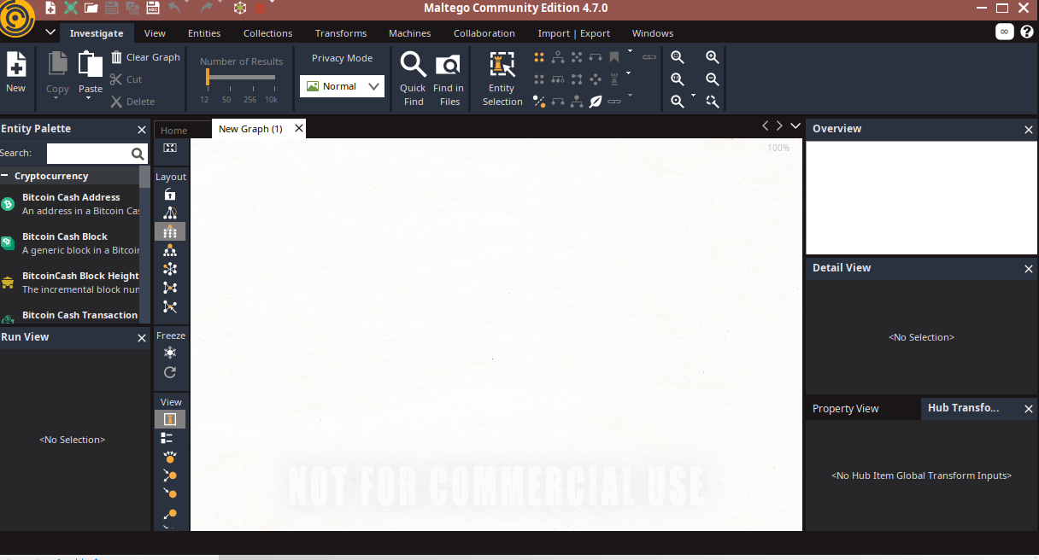
- Drag and drop the domain entity to the New graph
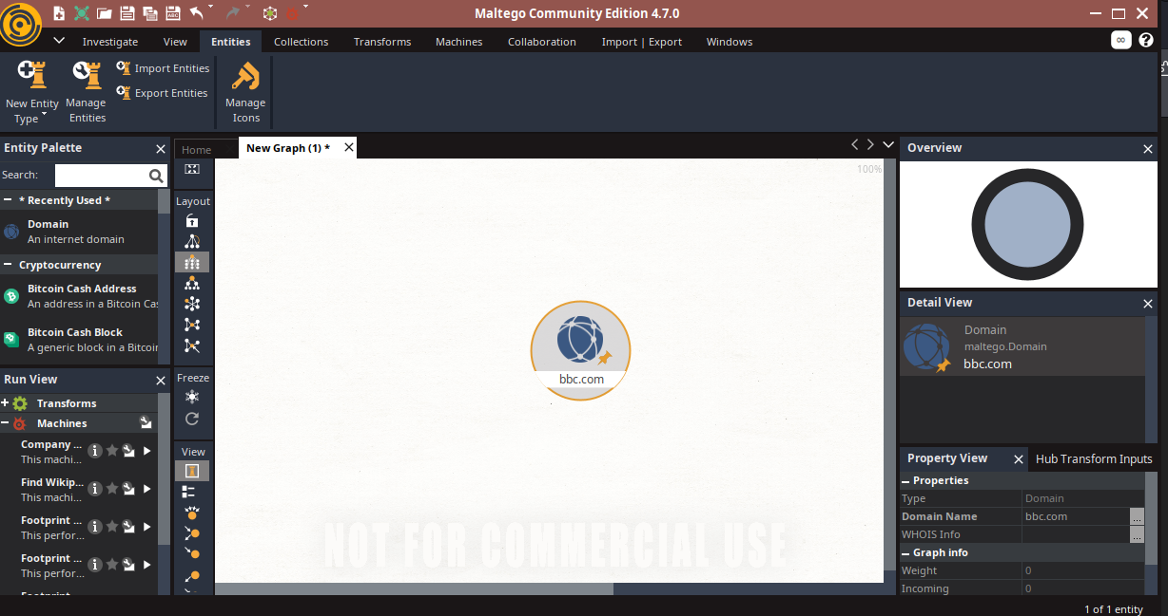
- Right click on bbc.com to see available transforms
- Then from it select DNS name to DNS to see available domains as shown below
